VICTORIOUS EDUCATION SERVICES
P. 1 LITERACY LESSON NOTES FOR TERM TWO, 2017

WEEK THREE:
DAY: Monday
LESSON: FOUR and FIVE
THEME: The human body and health
SUBTHEME: Immunisation diseases
CONTENT: Immunisation

Immunization is the giving of a vaccine to prevent diseases. It is the vaccination given to children to prevent the killer diseases

The immunisable diseases

Polio
Measles
Whooping cough
Diphtheria

Meningitis
Tuberculosis
Tetanus
Haemophilus influenza

ACTIVITY 1

Fill in the missing letters

P_ lio
Me_ sl_s
Wh_ _ping co_ gh
Dip_ th_ ria
Tube _culos _s
M_ng_tis
Tet_n_s
H_ emoph_lus
Infl_ _nza

ACTIVITY 2

Name these immunisable diseases

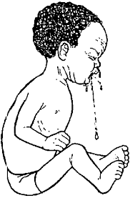
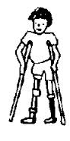______________________

Reference:
Fountain Science book 1 pg 64 – 66
A New Int. pr. Science bk 1 page 28 – 29
Mk pr. Sci. bk 1 pg 50

WEEK THREE:
LESSON:
THEME: THE HUMAN BODY AND HEALTH
SUBTHEME: Importance of Immunisation
CONTENT: Why do we immunise?

- To prevent the immunisable diseases
- To grow healthy
- It reduces the death rate.

Dangers of immunisable diseases (orally)

  - They can lead to death
  - They lead to poverty
  - They may lead to madness
  - Polio can lead to lameness
  - They can lead to deafness (measles.

Reference:
Integrated pri. Sci. bk 1 pg 35 – 38
Mk int. pri. Sci. bk 1 pg 49 – 52
Int. Pri. Sci. course bk 1 pg 31 – 34
A new Uganda pri. Int. sci. bk 1 pg 28 – 29

WEEK THREE:
DAY: Wednesday
LESSON: THREE and FOUR
THEME: Weather
SUBTHEME: Elements of weather
CONTENT: Elements of weather

Weather is the condition of a place at a given time.

Elements of weather
- Rainfall
- Cloud-cover
- Wind
- Sunshine

ACTIVITY

1. Write the following words correctly
cdolu cover
indw
nair fall

2. Underline the elements of weather
Polio, wind, T.B, sunshine, hut, rainfall

3. Name the four elements of weather
Reference:
Sharing our world bk 1 pg 30 – 38
SST Our home bk 1 pg 43

WEEK THREE:
DAY: Thursday
LESSON: SEVEN and EIGHT
THEME: Weather
SUBTHEME: Types of weather
CONTENT: Types of weather

 | 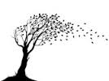
Sunny | Windy
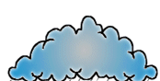 | 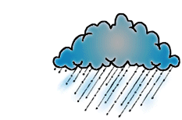
Cloudy | Rainy

ACTIVITY

1. Match the picture to the correct word

Sunny

Rainy

Cloudy

Windy

2. Underline the types of weather.
Rain, cloudy, sun, wind, sunny.

3. Write the four types of weather

Reference:

Mk Int. Pr. Sci. bk 1 pg 54 – 61
Monitor SST bk 1 pg 43 – 44
NPSC for Uganda Pri. Maths bk 1 pg 29

WEEK THREE:
DAY: Friday
LESSON: FIVE and SIX
THEME: WEATHER
SUBTHEME: Activities for different seasons
CONTENT: Activities done in dry season

There are two seasons
- Dry season
- Wet season

Activities done in the dry season (photocopied)
- Clearing the land
- Ploughing /digging
- Burning the bush
- Watering plants
- Drying seeds
- Harvesting

ACTIVITY:

1. Draw these activities done in the dry season
a) Watering plants b) burning bush
2. Circle the two seasons
Drying, wet season, sunny , dry season
3. List two activities done in dry season

LESSON TWO:
Clothes worn in a dry season
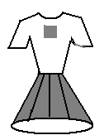White clothes shorts sleeveless/light clothes vest
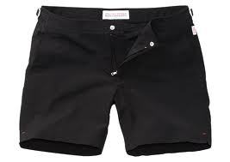
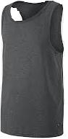

ACTIVITY 1:

1. Draw these clothes for the dry season
a) Vest b) shorts c) sleeveless
2. Write three clothes worn during the dry season

WEEKFOUR:
DAY: Monday
LESSON: THREE and FOUR
THEME: WEATHER
SUBTHEME: Activities for different seasons
CONTENT: Activities done in a wet season

Wet season is when it is raining too much.

Activities
- Planting
- Sowing seeds
- Growing crops
- Weeding

ACTIVITY 1

1. Write down three activities done in a wet season
2. What are the two people doing in the picture? (Photocopied work)

LESSON TWO:
Clothes worn during a wet season

- Jacket
- Coats
- Gum boats
- Sweaters
- Scarf
- Rain coat
- Umbrella

ACTIVITY

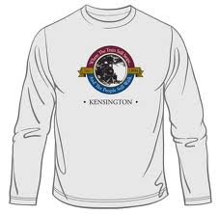
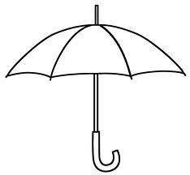
1. Name these clothes we wear in a wet season

Reference:
NPSC for Uganda Primary one pg 29
Mk Integrated Primary Science bk 1 pg 54 – 61
NPSC tr’s guide bk 1 pg 223
Fountain Primary Science bk 1 pg 52

WEEK FOUR:
DAY: Tuesday
LESSON: FIVE and SIX
THEME: WEATHER
SUBTHEME: Activities done in a wet season
CONTENT: Garden tools used in the garden by farmers

Tools

- Panga
- Slasher
- Rake
- Sickle
- Hoe
- Basket
- Watering can
- Knife
- Wheel barrow
- Spade

ACTIVITY 1

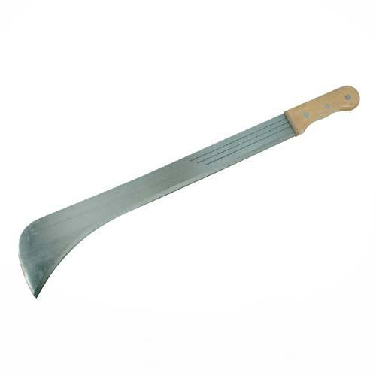
1. Name the garden tools
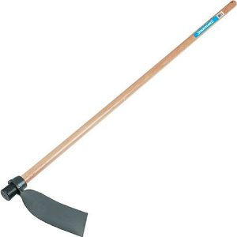
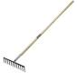
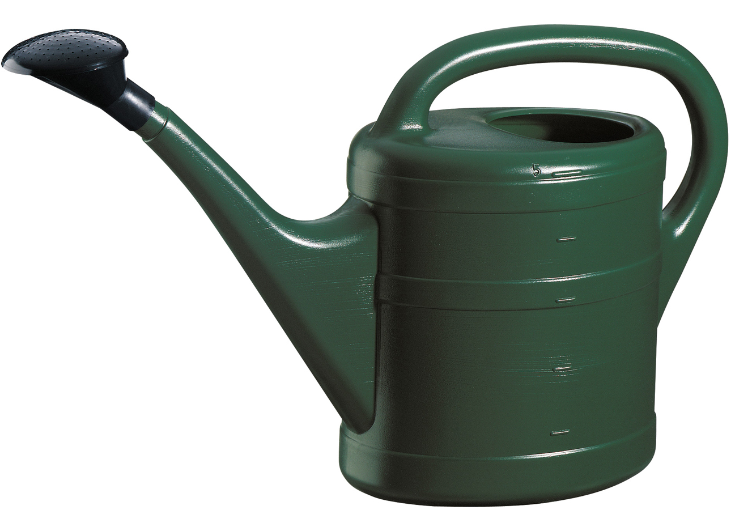
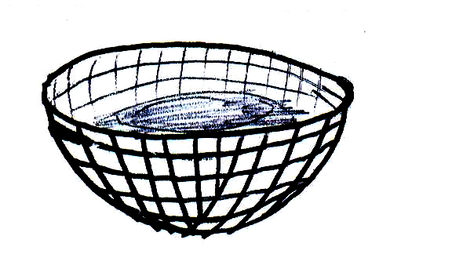

2. Draw the following garden tools
a) Panga b) wheel barrow c) spade d) knife

3. Tick the garden tools
Jacket, panga, scarf, hoe, sweater, rake.

Reference:
Mk Integrated Science bk 1 pg 24
Treacher’s guide resource book pg 29 – 32
NPSC for Uganda Primary one pg 29

WEEK FOUR:
DAY: Wednesday
LESSON: THREE and FOUR
THEME: WEATHER
SUBTHEME: Activities for different seasons
CONTENT: Uses of different garden tools

Hoe – digging
Panga – cutting
Knife – peeling/pruning
Slasher – slashing
Rake – collecting rubbish
Watering can – watering crops
Sickle – for cutting grass
Basket – carrying seeds and food
Wheel barrow – carrying tools

ACTIVITY

1. Match the garden tools to their uses correctly
Slasher digging
Rake slashing
Hoe collecting
Panga carrying
Basket watering
Watering can cutting
2. We use a __________ for watering crops.
3. We use a __________ when digging.

Reference:
Integrated Primary science bk 1 pg 24
Teacher’s resource bk 1 pg 29 – 32
NPSC for Uganda Primary one pg 29

WEEK FOUR:
DAY: Thursday
LESSON: FIVE and SIX
THEME: WEATHER
SUBTHEME: Activities for different seasons
CONTENT: Uses of the rain water.

Rain gives us water and it is the main source of water
- It waters our crops
- It makes the soil soft
- It cools down the temperature
- For plants to grow

Other uses of rain water
- for drinking
- for cooking
- for washing
- for bathing
- for swimming
- for transport on lakes
- for building houses
- for animals to drink
- for factories /industries

ACTIVITY
1. Write three uses of rain
2. Draw these uses of rain water
a) Cooking b) bathing c) swimming d) washing
3. We use water for _____________ and ______________

Reference:
Integrated Science book 1 pg 60
Mk Teacher’s guide bk 1 pg 60

WEEK FIVE:
DAY: Friday
LESSON: 5 and 6
THEME: Weather
SUBTHEME: Effects of weather
CONTENT: Dangers of rain (heavy/much)

- Too much rain destroys houses
- It causes floods
- It breaks roads and bridges
- It spoils crops
- It spreads diseases
- It kills people (floods)

ACTIVITY
1. Name this danger of too much rain. (Photocopy from; Int. Pr. Sci. bk 1 pg 59)

Reference:
Monitor SST bk 1 pg 46
Mk Int. Pri. Sci. bk 1 pg 59

WK: 5 Monday
LESSON: THREE and FOUR
THEME: Weather
SUBTHEME: Effects of weather
CONTENT: Sunshine

The sun is the natural source of light and heat

Uses of sunshine
- It gives us light and heat
- It dries our clothes
- It helps plants to grow well
- It dries our crops (seeds, grains)
- It helps our bodies to make vitamin D

ACTIVITY
1. Fill in correctly about sunshine
a) Sunshine gives us _________ and _____________
b) It helps our bodies to make vitamin ____________
c) It ____________ our clothes.
d) It helps the plants to ___________

2. Name the use of sunshine

Reference:
Mk Int. Pri. Sci. bk 1 pg 54 – 55

WEEK: FIVE
DAY: Tuesday
LESSON: FIVE and SIX
THEME: Weather
SUBTHEME: Effects and management of weather
CONTENT: Dangers of much sunshine

- It dries our plants
- It causes drought
- It causes thirst
- It spreads diseases i.e, flu as a result of much dust.
- Animals die due to lack of grass

Activity (oral practice)

Reference:
Monitor SST bk 1 pg 45
Mk SST bk 1 pg 83 – 84

WEEK FIVE:
DAY: Thursday
LESSON: SEVEN and EIGHT
THEME: WEATHER
SUBTHEME: Effects and management of weather
CONTENT: Soil erosion (practical lesson)

What is soil erosion?
Soil erosion is the washing away of top soil by running water/wind.

Ways of controlling soil erosion
- By planting trees/grass.
- By digging trenches
- By terracing
- By mulching (covering grass in the garden)

Activity
Excursion

WEEK FIVE:
DAY: Friday
LESSON: FIVE and SIX
THEME: Weather
SUBTHEME: Effects and management of weather
CONTENT: Wind

Wind is moving air

Uses of wind

- Wind helps plants to grow well.
- We breath in wind (air).
- Wind makes kites to fly.
- It helps boats to move on water.
- It is used for winnowing.
- It helps fire to catch well.
- It dries our clothes.
- It runs wind mills.

ACTIVITY
1. ________ is moving air.
2. Match these uses of wind.

Helps fire to catch

For winnowing

It flies a kite

3. Draw these uses of wind.
a) It moves boats b) Helps plants to grow well

Reference:
Mk Primary Science bk 1 pg 76
Fountain Primary Science bk 1 pg 45 – 46

LESSON TWO: Dangers of wind

- It breaks houses
- Strong wind bends plants
- It breaks trees

ACTIVITY

1. Draw the dangers of much wind.
a) It breaks trees b) It destroys houses

Reference:
Fountain Primary Science bk 1 pg 48 – 49

WEEK SIX:
DAY: Monday
LESSON: 5 and 6
THEME: Accidents and safety
SUBTHEME: Accidents and safety at home.
CONTENT: Dangerous objects

Dangerous objects
Are objects that can cause harm to us.

Examples of dangerous / sharp objects.
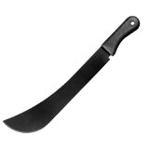
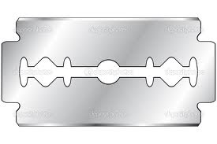
Razor blade nails safety pins panga

fire barbed wire stones broken bottles
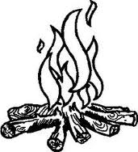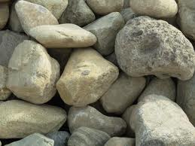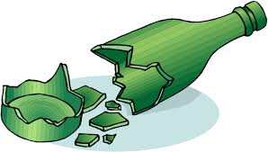

Activity

1. Draw these sharp objects that can harm us.

Fire
Razor blade
Nail
Barbed wire
Stones
Broken bottles
Panga

2.Fill in the missing letters
a) P_nga b) F_re c) razor bl_de d) st_nes

Reference:.
Mk Integrated Primary Science bk 1 pg 68
NPSC for Uganda bk 1 pg 32

WK: 6 Wednesday
LESSON: 4 and 6
THEME: Accidents and safety
SUBTHEME: Accidents at home.
CONTENT: Describing accidents at home

An accident is a sudden happening which causes harm to the body.

Accidents at home
- Cut by a knife
- Falling from a tree
- Burnt with hot water
- Shocked by electricity
- Taking poison
- Burnt by fire
- Drowning in water/Septic tanks
Activity
Draw these accidents

Drowning | Fracture | Cuts | Burns

Reference:
Mk Integrated Science bk 1 pg 68

WK: 6 Thursday
LESSON: 7 and 8
THEME: Accidents and safety
SUBTHEME: Accidents and safety at home.
CONTENT: Prevention of accidents at home

- Avoid keeping medicine near the children
- Avoid playing near fire and water sources.
- Avoid climbing tall trees.
- Avoid walking in bushes.
- Avoid playing with electricity.
- Don’t play with sharp objects.
- Avoid walking bear footed.
- Avoid playing with blades.
- Keep medicine a way from the children.

Activity (Oral work - practice)
1. Give the ways of preventing accidents

Reference:.
Mk Integrated Primary Science bk 1 pg 68 – 69
A new Uganda Primary Integrated Science bk 1 pg 39 – 41
Fountain Primary Science for Uganda bk 1 pg 29 – 38

WK: 6 Friday
LESSON: 5 and 6
THEME: Accidents and safety
SUBTHEME: Accidents on the way to school and back home.
CONTENT: Accidents on the way

- Snake bites
- Stings

- Electric shocks by the road sides
- Stings
- Sprain
- Insect bites
- Dog bites
- Strain
- Fracture
- Dislocation

Activity 1
1. List down any four accidents caused on the way
2. Draw these accidents on the way to and from school.
a) Fracture b) snake bites c) Dog bites

Activity 2
Name the accidents on the way to school.

Reference:.
Mk Integrated Primary science bk 1 pg 69
Fountain primary science for Uganda bk 1 pg 29 – 33
Monitor SST pupil’s book 1 pg 3
Mk standard SST bk 1 pg 45

WK: 6 Friday
LESSON: 5 and 6
THEME: Accidents and safety
SUBTHEME: Accidents at school and their causes.
CONTENT:

- Cuts and injuries
- Drowning
- Fracture
- Poisoning
- Burns
Causes of accidents at school
- Running
- Playing rough games
- Throwing stones
- Fighting
- Over loading
- Speeding

Activity 1
1. Fill in the missing letters in the accidents at school
a) dr_wning b) Po_soning c) f_lling d) fr_cture e) b_rns
2. Draw a person drowning in a pool.

Activity 2
1. Draw these causes of accidents at school

Throwing stones | Running | Fighting

2. Write two causes of accidents at school.

Reference:.
NPSC tr’s guide bk 1 pg 33
Mk Integrated Primary Science bk 1 pg 70
Fountain Primary Science Tr’s Guide pg 39
Fountain Primary Science bk 1 pg 29 – 33

WK: 6
LESSON: 5 and 6
THEME: Accidents and safety
SUBTHEME: Accidents on the way
CONTENT: Safe ways of walking to and from school (Road signs)

- Walking by the roadside (pavement)
- By following the road signs.
- By looking left to right and then left again, finally cross the road.
- By not playing on the road.
- Wait for the elder person or policeman to help you cross the road

Activity 1 (practical work)

1. Give ways of walking to school or back home safely.
2. Why are we not supposed to play on the road?

Reference:.
Mk Standard SST pupils book 1 pg 6 – 7
Our lives Today bk 1 pg 6 – 7
Monitor SST pupil’s book 1 pg 4 – 7
Comprehensive SST bk 1 pg 7 – 9

WK:
LESSON:
THEME: Accidents and safety
SUBTHEME: Dangers of accidents
CONTENT: What happens when you get an accident?

Dangers of accidents

You can become;

- Lame
- Blind
- Deaf
- Die (death)
- Madness

Activity
1. List four dangers of accidents
2. Circle the dangers of accidents
Falling, lameness, poisoning, death, madness
3. Draw this danger of an accident
Lameness

Reference:

Fountain Primary Science bk 1 pg 30
Mk Integrated Primary Science bk 1 pg 68 – 69

WK:
LESSON:
THEME: Accidents and safety
SUBTHEME: Safe ways of using the road.
CONTENT: Road signs

Road signs help us to cross the road safely
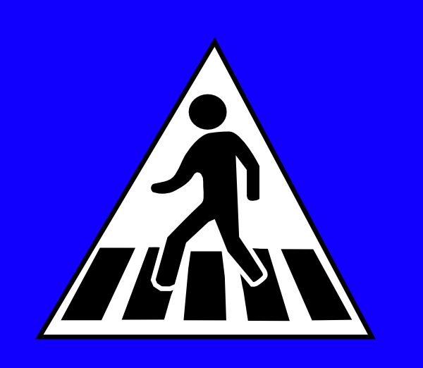
The road signs
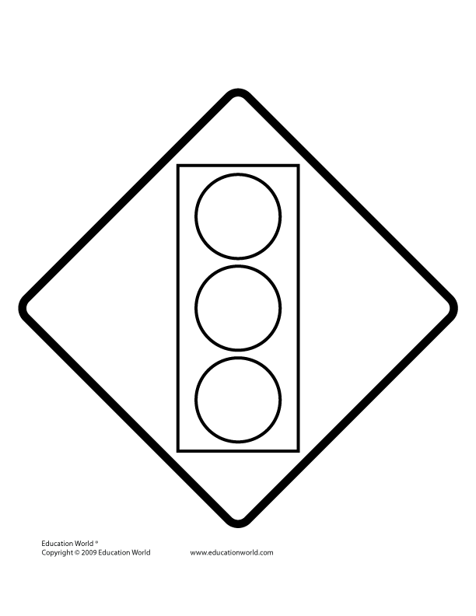
Traffic lights zebra crossing


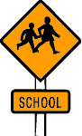
School a head parking



No Parking bridge

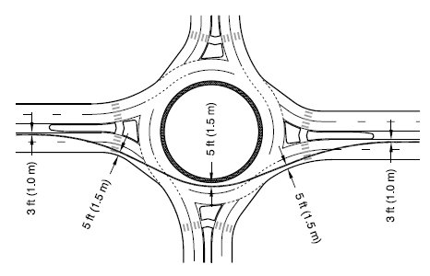

Humps round about

Activity
1. Draw these road signs

- Traffic lights
- Parking
- School ahead
- No parking
- Zebra crossing
- Bridge

2. Match these road signs

School a head

Bridge

Traffic lights

3. Underline the road signs
Burns, No parking, blind, humps, bridge

Reference:.
Comprehensive SST bk 1 pg 89
Our lives today SST bk 1 pg 6 – 7
Monitor SST bk 1 pg 4 – 6
Mk Standard SST bk 1 pg 7

WEEK 7: REVISION FOR MID-TERM EXAMINATIONS

THEME: Human body and health

1. Draw people suffering from these immunisable diseases
a) measles b) polio c) tetanus
2. Tick the immunisable diseases
Flu, polio, headache, tetanus, cough

Weather
1. Write the words correctly
a) cdolu cover ______ b) idnw ______ c) uns-shine ______ d) nair-fall ________
2. Name he four elements of weather.
3. Draw these clothes for a dry season
a) vest b) shorts c) sleeveless
4. Name the gardern tools
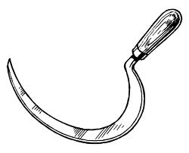

______________ _______________ _____________ _______________

5. Match these garden tools
Hoe watering crops
Panga digging
Knife carrying tools
Watering can pruning
Wheel barrow cutting

6. Name these sources of water

Accidents and safety
1. Draw these sharp objects
a) panga b) nail c) barded wire d) fire
2. Draw two accidents at school
a) drowning b) Fracture

WK: 7 Thursday
LESSON: 7 and 8
THEME: Accidents and safety
SUBTHEME: First aid
CONTENT: First aid

First aid is the first treatment given to a casualty before taken to the hospital

Things that help in first aid

Sack stickd ambulance stretcher

Lesson two
Things in a first aid box
Cotton Pair of scissors Plaster Bandage

Spirit Tweezers Tablets Razor blade

Pin Syringe needle
Activity 1
1. _________ is the first treatment given to a casualty before taking him/her to the hospital.
2. Draw an ambulance.

Activity 2
1. Draw these things got in a first aid box
Cotton wool, plaster, tablets, bandage, spirit, Pair of scissors
2. Fill in the missing letters
a) Pl_ster b) t_blets c) b_nd_ge

Reference:.
NPSC tr’s guide bk 1 pg 256
NPSC book 1 pg 34

WK: 8 Monday
LESSON: 3 and 4
THEME: Accident and first aid
SUBTHEME: First aid
CONTENT: Why do we give first aid?

We give first aid to;
- Reduce pain
- To prevent more injury
- Avoid death
- Stop bleeding
- Save life

Activity 1
1. Give five reasons why we give first aid.
- To reduce ____
- To prevent more_____
- To avoid _____
- To stop ____
- To save _____
2. Draw three things found in the first aid box.
a) plaster b) razor blade c) pin

Reference:.
NPSC for Uganda primary one tr’s guide pg 225
Mk Int. Pr. Sci. bk 1 pg 71 – 72

WK: 8 Tuesday
LESSON: 5 and 6
THEME: Living together
SUBTHEME: Family relationship
CONTENT: An extended family

An extended family is where we find father, mother, children and their relatives.

Other members;

- Uncle
- Aunt
- Nephew(boy)
- Niece (girl)
- Grandmother
- grandfather

Activity 1
1. An ________ family is where we find father, mother, children and their relatives.
2. Draw these members in an extended family.
a) grandmother b) grandfather
3. The sister to my father is an ____________ (uncle, aunt)
4. Tick the other relatives in an extended family
Father, cousin, man, grandmother, girl, grandfather, baby, uncle, aunt.
5. Match correctly

Grandmother

Aunt

Grandfather

6. The brother of my mother is an ___________
7. The father of my father is my ____________

Lesson two
Basic needs of a family

a) water b) clothes c) shelter d) food

Other needs
a) medicine (medical care) b) money

Activity 2
1. Write the four basic needs of a family
2. Name the basic needs of a family below

3. Tick the basic needs of a family
Clothes book food snake shelter

Reference:.
NPSC for Uganda primary one pg 17
Mk Pri. SST bk 1 pg 23
Comprehensive SST bk 1 pg 40
Monitor SST bk 1 pg 22 -25

WK:
LESSON:
THEME: Living together
SUBTHEME: Family relationship
CONTENT: Ways of living together in the community

Working together

Activity 1 ( practical lesson)

- cleaning the roads
- cleaning the well
- sharing
- caring
- cleaning the compound
- digging (farming)

Activity 2
1. Write down three ways of working together.
2. Draw your self helping at school

Reference:.
NPSC for Primary One pg 36
Monitor SST bk 1 pg 16

WK: 10
LESSON: 1 and 2
THEME: Food and nutrition
SUBTHEME: Names and sources of food
CONTENT: Names of foods

Food is some thing good to eat or drink
Examples;

Fish
Peas
Millet
Bananas
Eggs
Simsim
Potatoes
Rice
Pumpkins
Cabbage
Maize
Beans
Carrots
Milk
Pineapple
Posho Chicken
Meat
Bread
Cassava

Oranges Yams

Activity
1. _________ is some thing good to eat or drink.
2. Name the food below
(photocopied work – Monitor English course bk 1 pg 53)

3. Read and draw these foods
a) cassava b) chicken c)eggs

Activity 2
1. Circle the names of food
Milk, tree, cassava, doll, cabbage, dress, carrots, vest, millet

WK: 10
LESSON: 3 and 4
THEME: Food and nutrition
SUBTHEME: Names and sources of food
CONTENT: Sources of food

Sources of food is where we get food from. They include;

- water bodies
- Animals
- Plants

Activity1
1. Write down four sources of food
2. Draw the sources of food below
a) shop b) water
3. We get fish from ________( water, garden)
4. We get food from ______ , ________ and garden.
5. We get _____ and _____ from a hen. (milk, eggs, chichen)

Activity 2
1. Match the foods to their sources

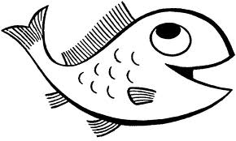
Animals

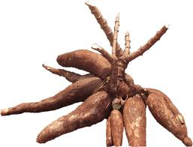 Water

Plants

Reference:.
Fountain Primary Science bk 1 pg 52 – 56
NPSC for Uganda Primary 1 pg 311 (tr’s guide)
NPSC for Uganda Primary 1 pg 39
WK: 10
LESSON: 5 and 6
THEME: Food and nutrition
SUBTHEME: Uses of food
CONTENT: Why do we eat food?

- Food makes us strong/food gives us energy
- Food makes out bodies to grow well
- Food makes us look healthy.

NB – We sell food and get money

Activity
1. Why do we eat food
a) To get _________ b)To look ________ c)To be _________
(strong, grow well, energy, healthy)

2. We sell food and get ________

Reference:.
Fountain Pri. Sci. bk 1 pg 56 -57
NPSC bk 1 pg 39 – 40

WK: 10
LESSON: 6 and7
THEME: Food and nutrition
SUBTHEME: Keeping food safe
CONTENT: Ways of keeping food safe (practical lesson – first)

- By washing fruits before eating them.
- By washing food before eating/cooking it.
- By cooking food well.
- By storing it in a safe and clean place/granary.
- By washing hands before eating food.
- By serving food in clean containers
- By cooking and serving food in a clean place.

Ways of keeping food for a long period of time. (preserving food)
- Salting food
- Sun drying food
- Tinning food
- Putting it in a fridge

ACTIVITY

1. Children learn how to keep safe practically

Reference:.
NPSC primary one pg 40 – 41
Fountain primary science bk 1 pg 60

WK: 10
LESSON: 8 and 9
THEME: Food and nutrition
SUBTHEME: Importance of keeping food safe
CONTENT: Why we keep food safe (practical lesson)

- To avoid rotting
- To avoid bad smell.
- To avoid diseases.
- To avoid contamination i.e., germs, flies

Activity
1. We keep food safe to avoid _____________
2. To avoid ___________
3. To avoid ___________

Reference:
NPSC primary one pg 41

Revision Exercise
1. Circle the immedicable diseases

Flu polio fever diphtheria cold whooping cough mumps measles malaria

Weather
2. _________ is moving air. (Rain, wind)
3. Circle the types of weather
Rainfall sunny cloud covers rainy well cloudy sun windy

4. Write the 4 elements of weather
5. Draw the types of weather
a) sunny b) windy c) cloudy

6. Name these garden tools.

7. The main source of water is ____________

Accidents and safety

1. Name these dangerous things

2. Fill in the missing letters

P_anga f_re razorbl_de st_n_s barbed w_re

3. Draw these accidents
a) Car knocks b) drowning c) falling from a tree

4. a) Name any two accidents at home
b) Name any two causes of accidents at school

Accidents and safety

1. Draw these road signs
a). Traffic lights b) no parking c) school d) no parking
e) Zebra f) bridge

2. Match the road signs to their words

School a head

Bridge

Traffic lights

3. Draw these things in first aid
a) Ambulance b) cotton wool c) plaster d) razor blade

Living together
1a). An_________________ family is a family where we find father, mother, children and relatives.
b). Draw these members in an extended family.

Grandmother | Grandfather | Baby | Father

2. Match correctly

Grandmother

Aunt

Grandfather

3. Write the four basic needs of a family.
1. _________________________. 2. _________________________.

3. _________________________. 4. _________________________.

Food and nutrition.

1. Name the food.

_______________________.

______________________.

_______________________.

2. Tick the sources of food.
Water bread animals mother Plants

3. We get fish from the ____________________. (Lake, box)

4. We eat food to ____________________. (Grow, die)

5. Draw these sources of food.

Animal | Water

END.

